Title

Author¹
¹ Affiliation

Main text…….

Any style, fonts, styles would be fine if this abstract includes
- Title
- Authors’ name
- Affiliation
- Photo (hopefully) of the presenting author with his/her brief introduction
- Abstract of the presentation + symbolic graphics
- Key references
The upper limit is 10 pages…

Deadline: Feb. 17, 2020
Submit to: frjp2020@chem.kumamoto-u.ac.jp
Format: word (or LateX) + pdf

The next page is an example of the abstract.

Kumamoto and Chemoinformatics: Lessons from Geochemistry

Kumamon¹
¹ Kumamoto Prefecture

In this lecture, I will discuss about how the geochemistry in Kumamoto can be related to chemoinformatics.
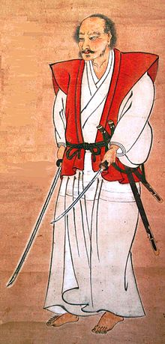

Figure 1. Volcano Eruption of Mt. Aso (Nakadake). The phenomena can be considered as molecule and crystal generator for chemoinformatics and materials informatics.
Figure 2. Miyamoto Musashi who used two swords for fighting. He was an author of the best seller textbook named “Gorinno-sho” for samurai warriers. The book was written in Reigando Cave near Unganzenji Temple in Kumamoto. The text-mining is a key technology common to chemoinformatics.

Kumamon (Ph. D.)
Science Ambassador of Kumamoto Prefecture, Japan

2016 Ph. D. in Kumamoto University
(Supervisor: Assoc. Prof. Manabu Sugimoto)
Research Field: Computational Geochemistry
Hobby: Gymnastics
E-mail: kumamon@kuma-pref.or.jp
URL: https://www.youtube.com/watch?v=alxWC-kNemc (About Onsen)
https://www.youtube.com/watch?v=GwmeKHXYqzI (About Gymnastics)

*Please introduce yourself with your photo. Any description (contents) would be fine.

